**Project Design Phase-II**

**Data Flow Diagram & User Stories**

|  |  |
| --- | --- |
| Date | 31 January 2025 |
| Team ID | LTVIP2025TMID32140 |
| Project Name | HealthAI: Intelligent Healthcare Assistant Using IBM Granite |
| Maximum Marks | 4 Marks |

**Data Flow Diagrams:**

A Data Flow Diagram (DFD) is a traditional visual representation of the information flows within a system. A neat and clear DFD can depict the right amount of the system requirement graphically. It shows how data enters and leaves the system, what changes the information, and where data is stored.



**Example:** [**(Simplified)**](https://developer.ibm.com/patterns/visualize-unstructured-text/)

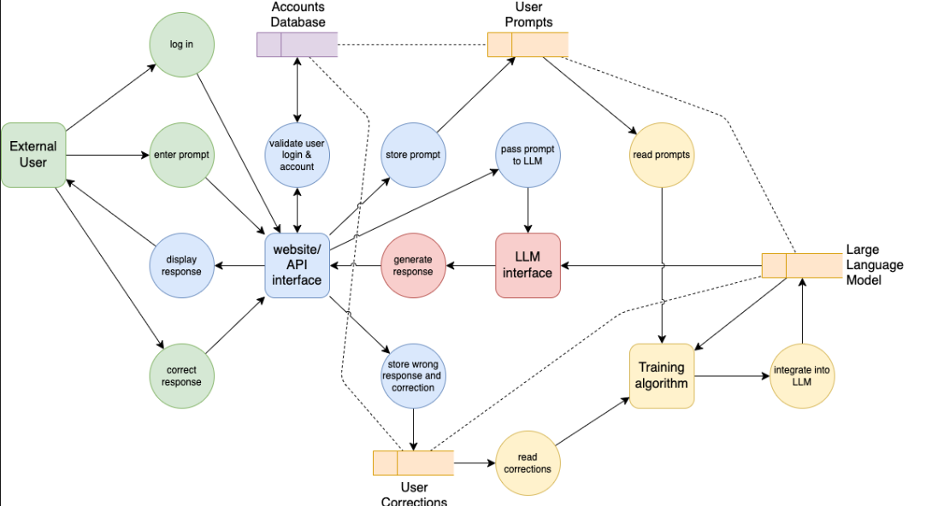

**User Stories**

Use the below template to list all the user stories for the product.

| **User Type** | **Functional Requirement (Epic)** | **User Story Number** | **User Story / Task** | **Acceptance criteria** | **Priority** | **Release** |
| --- | --- | --- | --- | --- | --- | --- |
| Customer (Mobile user) | Registration | USN-1 | As a user, I can register with email & password | I can access dashboard after successful registration | High | Sprint-1 |
| Customer (Web user) | Login | USN-2 | As a user, I can log in using email & password | I am redirected to the home/dashboard | High | Sprint-1 |
| Customer (Web user) | Symptom Identifier | USN-3 | As a user, I can enter symptoms to identify possible diseases | I see predicted diseases with confidence text | High | Sprint-1 |
| Customer (Web user) | Home Remedies | USN-4 | As a user, I can enter a disease name to get natural home remedies | I see 2–5 home remedies for the entered disease | Medium | Sprint-1 |
| Customer (Web user) | Chatbot | USN-5 | As a user, I can chat with an AI health assistant for any medical question | I receive coherent responses in real-time | High | Sprint-2 |
| Customer (Web user) | Voice Input | USN-6 | As a user, I can give symptom input using voice | My spoken text is converted and processed | Medium | Sprint-2 |
| Customer (Web user) | Image Upload | USN-7 | As a user, I can upload images for future disease detection | I see confirmation message after upload | Low | Sprint-2 |
| Customer Care Executive | Help/Logout | USN-8 | As a user, I can access a help section to understand how the app works | I read FAQs and guidelines | Low | Sprint-2 |